Practice of process communication and process synchronization
SHEN XINNAN
June, 2017
1. Content of Design
There are 2 personal ticket selling windows, 1 personal changing/refunding ticket window, and 3 automatic ticket selling machines in the station ticketing hall. The ticket hall has a capacity of 200 people and has an entrance and an exit. The exit/entry door allows only one person to pass at a time. When the customer arrives in the front of the ticket hall, they will queue up to enter the ticket hall. When the customer enters the lobby, he or she will choose the manual or automatic ticketing service according to his own requirements and preferences. If he or she wants to have their ticket signed or refunded, the manual changing/refunding ticket window can be the only one to be chosen. When the process of refunding/changing/purchasing ticket is completed, the customer will leave in order from the exit. As for the ticket seller of the manual service window, when there is a customer, the selling/changing/refunding ticket service is provided to the customer in turn, and when there is no customer the ticket seller has to wait. Design synchronization and mutual exclusion algorithms for customer processes and ticket seller processes using semaphores and PV operations.
2.Requirement
(1) Suppose a service time interval such as 7:00-20:00, or limit the maximum number of customers;
(2) The arrival time of the customers is random, the purchasing/changing/refunding ticket service is random, and the manual/automatic ticket sales are selected randomly. When a specific ticket purchase method is selected, customers choose the queue with the least number of people and the random situation needs to be implemented by random number simulation;
(3)It is necessary to distinguish between different manual service windows and different machines;
(4)The time of selling/changing/refunding ticket should be implemented by a random number.
3. Main Data Structure and Algorithms used
3.1.Main Data Structure used in the Program
（1）A structure of Customer ID

struct ID_STRUCT//ID
{
int num;
}；
（2）A structure of current time
SYSTEMTIME Time;
（3）arraies of customer handle and threadid
HANDLE hCustomer[MAX_NUM_CUSTOMER]；
DWORD dwThreadIdArray_Customer[MAX_NUM_CUSTOMER];
3.2.The Algorithms used in the program
（1）synchronization and mutual exclusion algorithms for processed
semaphore s_enter, s_exit, s_output, s_Machine,
s_person,mutex_change,mutex_buy1,mutex_buy2,mutex_Machine1, mutex_Machine2, mutex_Machine3, s_Machine1, s_Machine2, s_Machine3;
semaphore s, s_serverchange, s_serverbuy1, s_serverbuy2, s_serverMachine1, s_serverMachine2, s_serverMachine3, s_custchange, s_custbuy1, s_custbuy2, s_custMachine1, s_custMachine2, s_custMachine3;
int person_in = 0,waiting_in = 0,waiting_out = 0,waiting_person1 = 0,
waiting_person2 = 0,waiting_Machine1 = 0,waiting_Machine2 = 0,
waiting_Machine3 = 0,waiting_change = 0;
s_enter.value=1;
s_exit.value=1;
s_output.value=1;
s_Machine.value=1;
s_person.value=1;
mutex_change=1;
mutex_buy1.value=1; mutex_buy2.value=1;
mutex_Machine1.value=1; mutex_Machine2.value=1; mutex_Machine3.value=1;
s_Machine1.value=1; s_Machine2.value=1; s_Machine3.value=1;
s.value=200;
s_serverchange.value=0;
s_serverbuy1.value=0; s_serverbuy2.value=0;
s_serverMachine1.value=0; s_serverMachine2.value=0; s_serverMachine3.value=0;
s_custchange.value=0;
s_custbuy1.value=0; s_custbuy2.value=0;
s_custMachine1.value=0; s_custMachine2.value=0; s_custMachine3.value=0;
process customer(int i)//Customer Process
{
P(s);
P(s_enter);
进入；
V(s_enter);
Receive_Service();//Call a function
P(s_exit);
退出；
V(s_exit);
V(s);
}
process server1()//Manual Service Window 1 Process
{
while(1)
{
P(s_custbuy1);
P(mutex_buy1);
waiting_person1--;
V(s_serverbuy1);
V(mutex_buy1);
}
}
process server2()//Manual Service Window 2 Process
{
while(1)
{
P(s_custbuy2);
P(mutex_buy2);
waiting_person2--;
V(s_serverbuy2);
V(mutex_buy2);
}
}
process server_change()//Changing or Refunding Ticket Window Process
{
while(1)
{
P(s_custchange);
p(mutex_change);
waiting_change--;
V(s_serverchange);
V(mutex_change);
}
}
void Receive_Service()//Function of Receiving Service
{
int ser=rand()%4;
switch(ser)
{
case 0:
change_method();
break;
case 1:
change_method();
break;
case 2:
case 3:
Purchase_method();
break;
}
}
void change_method()//Function of Changing or Refunding Ticket
{
P(mutex_change);
waiting_change++;
V(s_custchange);
V(mutex_change);
P(server_change);
Changing or Refunding；
}
void Perchase_method()//Function of Purchasing Ticket
{
int way=rand()%2;
if(way==0) Machine_func();//Call Machine Service Function
else Person_func();//Call Manual Service Function
}
void Person_func()//Manual Service
{
Choose a queue with least waiting_person;
P(mutex_buy);
respective waiting_person+1;
V(s_custbuy);
V(mutex_buy);
P(s_serverbuy);
}
void Machine_func()//Machine Service
{
Choose a queue with least waiting_Machine;
P(mutex_Machine);
respective waiting_Machine+1;
V(mutex_Machine);
P(s_Machine);
Use the Machine to buy tickets;
V(s_Machine);
P(mutex_Machine);
respective waiting_Machine-1;
V(mutex_Machine);
}

(2)The process of Algorithm
①The whole process of customer
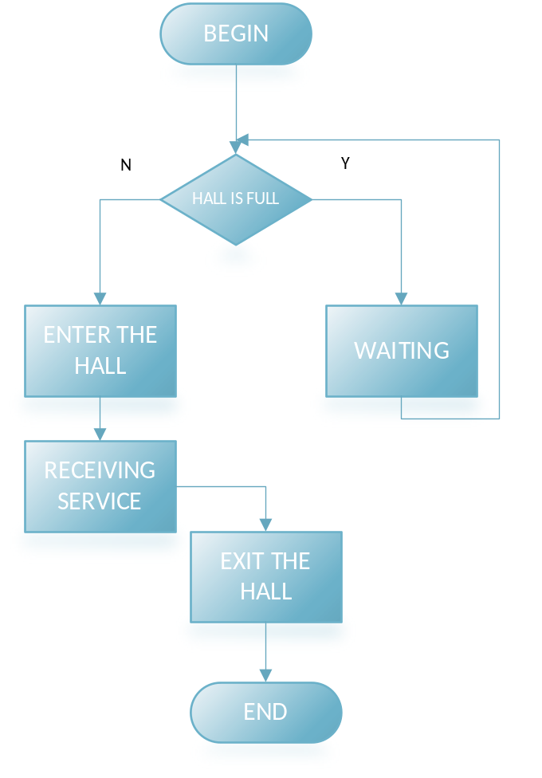

②The process of choosing methods
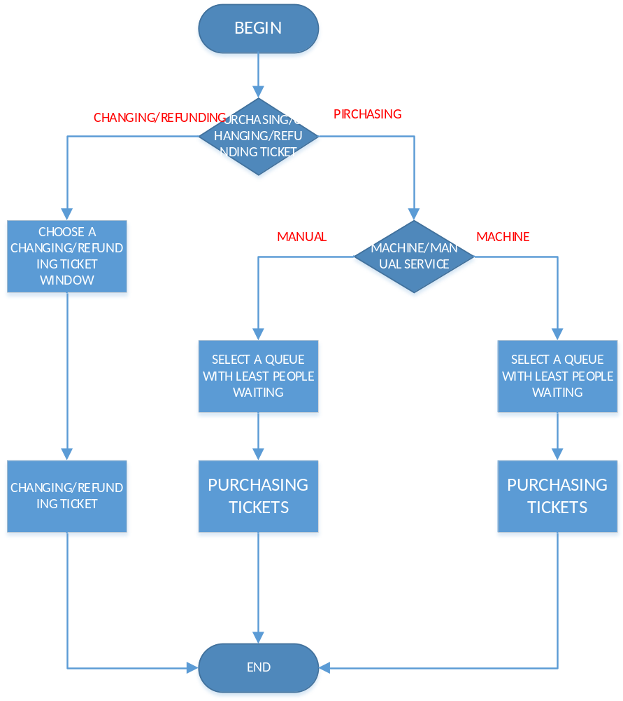
4.The respective functions of operations
4.1.Enter the critical section
s.Lock();
4.2.Exit the critical section
s.Unlock();
4.3.Create a thread
CreateThread(NULL,0,func,NULL,0,NULL);
4.4.create a semaphore
CreateSemaphore(NULL, initial value，biggest value，NULL);
4.5.P-Operation
WaitForSingleObject(s,INFINITE);
4.6.V-Operation
ReleaseSemaphore(s,1,NULL);
Note: Above Functions can only be used in Windows.
5. The result of the practice and the analysis of result
5.1.the result of the pratice
（1）initial result
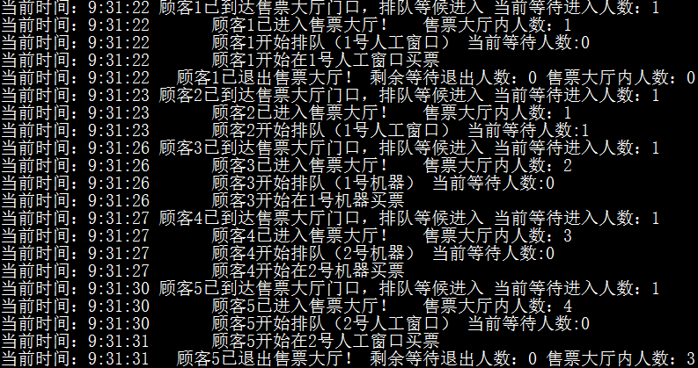
（2）random time result
①
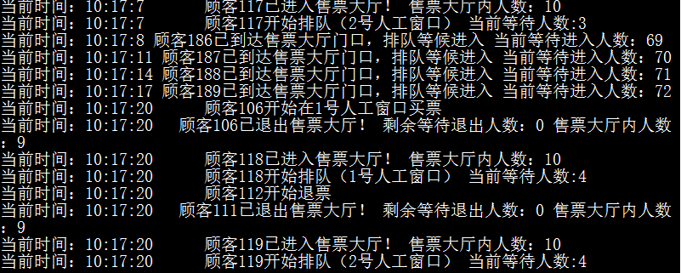
②
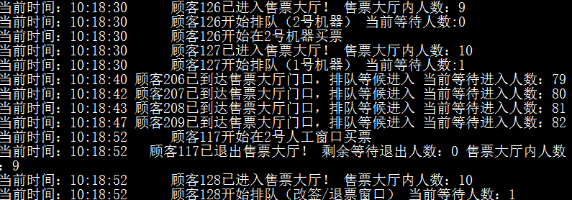

5.2.Analysis of the result
Firstly, Customer 1 entered the lobby and chose manual service window to purchase tickets. The choice is manual window 1 as there is no customer in front of every manual window. After a few minutes, customer 1 finished purchasing and exited the lobby.
Then, Customer 2 entered the lobby and chose manual service window to purchase tickets. The choice is manual window 1 as there is no customer in front of every manual window.
Additionally, Customer 3 entered the lobby and chose machine service to purchase tickets. The choice is machine 1 as there is no customer in front of every machine.
Afterwards, Customer 4 entered the lobby and chose machine service to purchase tickets. The choice is machine 2 as there is one customer in front of machine 1.
After that, Customer 5 entered the lobby and chose manual service window to purchase tickets. The choice is manual window 2 as there is one customer in front of manual window one.
……
The customers coming back are like this, according to the random number selection method, and then select the queue with the least waiting number. The designed service time in the program is 2 hours, so the program will finish after 2 hours of operation.
6. Conclusion
In this project, I used the principle of thread synchronization and mutual exclusion to implement a practical model of the ticketing hall queuing problem. In addition, I have also improved the skills of designing and developing software. This project allows me to master the design rationally and systematically from the big picture to the details as well as from simple item to complex item.

PS. Programming Code
/*
File name：Source.cpp
Project name：Server_Station.sln
*/

#pragma once
#pragma warning(disable : 4996)
#ifndef _CRT_SECURE_NO_WARNINGS
#define _CRT_SECURE_NO_WARNINGS
#ifndef _AFXDLL
#define _AFXDLL
#ifndef _WIN32_WINNT_MAXVER
#define _WIN32_WINNT_MAXVER
#include <iostream>
#include <conio.h>
//#include <atltime.h>
#include <afxmt.h>
#include <windows.h>
#include <time.h>

#define MAX_NUM_CUSTOMER 5000
#define CONTAIN_NUM_HALL 200
#define MAX_NUM_EACHQUEUE 200

#define P_OPERATION(semaphore) WaitForSingleObject(semaphore,INFINITE)
#define V_OPERATION(semaphore) ReleaseSemaphore(semaphore,1,NULL)
#define _Time_(t) GetLocalTime(t)
#define WAIT_MS(t) Sleep(t)
#define WAIT_S(t) Sleep(t*1000)
#define Err_Code() GetLastError()
#define Sem_Create(INI_,MAX_) CreateSemaphore(NULL,INI_,MAX_,NULL)
#define Until_Terminate_All_Threads(NUM,THREAD) WaitForMultipleObjects(NUM,THREAD,TRUE,INFINITE)
#endif
#endif
#endif
using namespace std;
typedef struct ID_STRUCT//ID
{
int num;
}DATA_CUST_ID,*DATA_POINTER_ID;
typedef SYSTEMTIME Current_Time;
typedef CCriticalSection Mutex_District;

Current_Time Time = { 0 };
Mutex_District s_enter, s_exit, s_output, s_Machine,
s_person,
mutex_change, mutex_buy1, mutex_buy2, mutex_Machine1, mutex_Machine2, mutex_Machine3, s_Machine1, s_Machine2, s_Machine3;
HANDLE s,
s_serverchange, s_serverbuy1, s_serverbuy2, s_serverMachine1, s_serverMachine2, s_serverMachine3, s_custchange, s_custbuy1, s_custbuy2, s_custMachine1, s_custMachine2, s_custMachine3;
INT person_sum_number = 0,
waiting_in_number = 0, waiting_out_number = 0,
waiting_person1_count = 0, waiting_person2_count = 0, waiting_Machine1_count = 0, waiting_Machine2_count = 0, waiting_Machine3_count = 0, waiting_change_refund_count = 0;

inline WORD Get_min_NUM(WORD a, WORD b, WORD c) {
return (a > b) ? min(b, c) : min(a, c);
}

UINT Init_all_Semaphore()
{

s = Sem_Create( CONTAIN_NUM_HALL, CONTAIN_NUM_HALL);
if (!s)
{
cerr << "信号量创建失败:" << Err_Code() << endl;
ExitProcess(1);
}
s_serverchange = Sem_Create( 0, 1);
if (!s_serverchange)
{
cerr << "信号量创建失败:" << Err_Code() << endl;
ExitProcess(1);
}
s_serverbuy1 = Sem_Create( 0, 1);
if (!s_serverbuy1)
{
cerr << "信号量创建失败:" << Err_Code() << endl;
ExitProcess(1);
}
s_serverbuy2 = Sem_Create( 0, 1);
if (!s_serverbuy2)
{
cerr << "信号量创建失败:" << Err_Code() << endl;
ExitProcess(1);
}
s_serverMachine1 = Sem_Create( 0, 1);
if (!s_serverMachine1)
{
cerr << "信号量创建失败:" << Err_Code() << endl;
ExitProcess(1);
}
s_serverMachine2 = Sem_Create( 0, 1);
if (!s_serverMachine2)
{
cerr << "信号量创建失败:" << Err_Code() << endl;
ExitProcess(1);
}
s_serverMachine3 = Sem_Create( 0, 1);
if (!s_serverMachine3)
{
cerr << "信号量创建失败:" << Err_Code() << endl;
ExitProcess(1);
}
s_custchange = Sem_Create( 0, CONTAIN_NUM_HALL);
if (!s_custchange)
{
cerr << "信号量创建失败:" << Err_Code() << endl;
ExitProcess(1);
}
s_custbuy1 = Sem_Create( 0, CONTAIN_NUM_HALL);
if (!s_custbuy1)
{
cerr << "信号量创建失败:" << Err_Code() << endl;
ExitProcess(1);
}
s_custbuy2 = Sem_Create( 0, CONTAIN_NUM_HALL);
if (!s_custbuy2)
{
cerr << "信号量创建失败:" << Err_Code() << endl;
ExitProcess(1);
}
s_custMachine1 = Sem_Create( 0, CONTAIN_NUM_HALL);
if (!s_custMachine1)
{
cerr << "信号量创建失败:" << Err_Code() << endl;
ExitProcess(1);
}
s_custMachine2 = Sem_Create( 0, CONTAIN_NUM_HALL);
if (!s_custMachine2)
{
cerr << "信号量创建失败:" << Err_Code() << endl;
ExitProcess(1);
}
s_custMachine3 = Sem_Create( 0, CONTAIN_NUM_HALL);
if (!s_custMachine3)
{
cerr << "信号量创建失败:" << Err_Code() << endl;
ExitProcess(1);
}

return 0;
}

UINT Change_Method(INT m = 0,INT id = 0)
{
mutex_change.Lock();
waiting_change_refund_count++;
_Time_(&Time);

V_OPERATION(s_custchange);
mutex_change.Unlock();

s_output.Lock();
cout << "当前时间：" << Time.wHour << ":" << Time.wMinute << ":" << Time.wSecond << "\t";
cout << "顾客" << id << "开始排队（改签/退票窗口）" //<< endl;
<< " ";
cout << "当前等待人数：" << waiting_change_refund_count << endl;
s_output.Unlock();
P_OPERATION(s_serverchange);
_Time_(&Time);//获得当前本地时间
s_output.Lock();
cout << "当前时间：" << Time.wHour << ":" << Time.wMinute << ":" << Time.wSecond << "\t";
if (m==0)
cout << "顾客" << id << "开始改签" << endl;
else if (m==1)
cout << "顾客" << id << "开始退票" << endl;
s_output.Unlock();

WAIT_S(35);

return 0;
}

UINT Machine_Selection(INT id = 0)
{
s_Machine.Lock();
INT i = Get_min_NUM(waiting_Machine1_count, waiting_Machine2_count, waiting_Machine3_count);
INT a = waiting_Machine1_count;
INT b = waiting_Machine2_count;
INT c = waiting_Machine3_count;
if (i==a)
{
s_Machine.Unlock();
mutex_Machine1.Lock();
waiting_Machine1_count++;
_Time_(&Time);
s_output.Lock();
cout << "当前时间：" << Time.wHour << ":" << Time.wMinute << ":" << Time.wSecond << "\t";
cout << "顾客" << id << "开始排队（1号机器）" << " ";
cout << "当前等待人数:" << waiting_Machine1_count - 1 << endl;
s_output.Unlock();

mutex_Machine1.Unlock();

_Time_(&Time);
s_Machine1.Lock();
s_output.Lock();
cout << "当前时间：" << Time.wHour << ":" << Time.wMinute << ":" << Time.wSecond << "\t";
cout << "顾客" << id << "开始在1号机器买票" << endl;
s_output.Unlock();

WAIT_S(35);
s_Machine1.Unlock();

mutex_Machine1.Lock();
waiting_Machine1_count--;
mutex_Machine1.Unlock();

}
else if (i==b)
{
s_Machine.Unlock();
mutex_Machine2.Lock();
waiting_Machine2_count++;
_Time_(&Time);
s_output.Lock();
cout << "当前时间：" << Time.wHour << ":" << Time.wMinute << ":" << Time.wSecond << "\t";
cout << "顾客" << id << "开始排队（2号机器）" << " ";
cout << "当前等待人数:" << waiting_Machine2_count - 1<< endl;
s_output.Unlock();

mutex_Machine2.Unlock();

_Time_(&Time);
s_Machine2.Lock();
s_output.Lock();
cout << "当前时间：" << Time.wHour << ":" << Time.wMinute << ":" << Time.wSecond << "\t";
cout << "顾客" << id << "开始在2号机器买票" << endl;
s_output.Unlock();

WAIT_S(35);
s_Machine2.Unlock();

mutex_Machine2.Lock();
waiting_Machine2_count--;
mutex_Machine2.Unlock();

}
else
{
s_Machine.Unlock();
mutex_Machine3.Lock();
waiting_Machine3_count++;
_Time_(&Time);
s_output.Lock();
cout << "当前时间：" << Time.wHour << ":" << Time.wMinute << ":" << Time.wSecond << "\t";
cout << "顾客" << id << "开始排队（3号机器）" << " ";
cout << "当前等待人数:" << waiting_Machine3_count - 1<< endl;
s_output.Unlock();

mutex_Machine3.Unlock();

_Time_(&Time);
s_Machine3.Lock();
s_output.Lock();
cout << "当前时间：" << Time.wHour << ":" << Time.wMinute << ":" << Time.wSecond << "\t";
cout << "顾客" << id << "开始在3号机器买票" << endl;
s_output.Unlock();

WAIT_S(35);
s_Machine3.Unlock();

mutex_Machine3.Lock();
waiting_Machine3_count--;
mutex_Machine3.Unlock();

}

return 0;
}

UINT Person_Selection(INT id = 0)
{
s_person.Lock();

INT i = min(waiting_person1_count, waiting_person2_count);
INT a = waiting_person1_count;
INT b = waiting_person2_count;
if (i==a)
{
s_person.Unlock();

mutex_buy1.Lock();
waiting_person1_count++;
_Time_(&Time);

V_OPERATION(s_custbuy1);
mutex_buy1.Unlock();

s_output.Lock();
cout << "当前时间：" << Time.wHour << ":" << Time.wMinute << ":" << Time.wSecond << "\t";
cout << "顾客" << id << "开始排队（1号人工窗口）" //<< endl;
<< " ";
cout << "当前等待人数:" << waiting_person1_count << endl;
s_output.Unlock();

P_OPERATION(s_serverbuy1);
_Time_(&Time);
s_output.Lock();
cout << "当前时间：" << Time.wHour << ":" << Time.wMinute << ":" << Time.wSecond << "\t";
cout << "顾客" << id << "开始在1号人工窗口买票" << endl;
s_output.Unlock();

}
else
{
s_person.Unlock();

mutex_buy2.Lock();
waiting_person2_count++;
_Time_(&Time);

V_OPERATION(s_custbuy2);
mutex_buy2.Unlock();
s_output.Lock();
cout << "当前时间：" << Time.wHour << ":" << Time.wMinute << ":" << Time.wSecond << "\t";
cout << "顾客" << id << "开始排队（2号人工窗口）" //<< endl;
<< " ";
cout << "当前等待人数:" << waiting_person2_count << endl;
s_output.Unlock();

P_OPERATION(s_serverbuy2);
_Time_(&Time);
s_output.Lock();
cout << "当前时间：" << Time.wHour << ":" << Time.wMinute << ":" << Time.wSecond << "\t";
cout << "顾客" << id << "开始在2号人工窗口买票" << endl;
s_output.Unlock();

}
return 0;
}

UINT Purchase_Method_Choice(INT id = 0)
{
srand(time(NULL));
LOOP: INT way = //0;
rand() % 3
switch (way)
{

case 1:

Person_Selection(id);
break;

case 2:

Machine_Selection(id);

break;
default:
goto LOOP;
break;
}

return 0;
}

UINT Receive_ServiceSort_Choice(INT id=0)
{
srand(time(NULL));
INT ser = //2;
rand() % 10;
switch (ser)
{
case 0:
Change_Method(0,id);
break;
case 1:
Change_Method(1,id);
break;
case 2:
case 3:
case 4:
case 5:
case 6:
case 7:
case 8:
case 9:
Purchase_Method_Choice(id);
break;
default:
return 1;
break;
}

return 0;
}

DWORD WINAPI Customer_Thread(LPVOID lp)//顾客线程
{
DATA_CUST_ID *pmda = (DATA_POINTER_ID)lp;
INT ID = pmda->num + 1;
P_OPERATION(s);
s_enter.Lock();
_Time_(&Time);
s_output.Lock();
cout << "当前时间：" << Time.wHour << ":" << Time.wMinute << ":" << Time.wSecond << "\t";
cout << "顾客" << ID << "已进入售票大厅！" << "\t";
waiting_in_number--;
person_sum_number++;
cout << "售票大厅内人数：" << person_sum_number << endl;
s_output.Unlock();
s_enter.Unlock();

Receive_ServiceSort_Choice(ID);
waiting_out_number++;

s_exit.Lock();
_Time_(&Time);
s_output.Lock();
cout << "当前时间：" << Time.wHour << ":" << Time.wMinute << ":" << Time.wSecond << " ";
cout << "顾客" << ID << "已退出售票大厅！" << " ";
waiting_out_number--;
person_sum_number--;
cout << "剩余等待退出人数：" << waiting_out_number << " ";
cout << "售票大厅内人数：" << person_sum_number << endl;
s_output.Unlock();
s_exit.Unlock();
V_OPERATION(s);
return 0;

}

DWORD WINAPI Server_Person1_Thread(LPVOID lp=NULL)
{
DATA_CUST_ID *pmda = (DATA_POINTER_ID)lp;
INT ID = 1;
while (1)
{

P_OPERATION(s_custbuy1);
mutex_buy1.Lock();
waiting_person1_count--;

V_OPERATION(s_serverbuy1);
mutex_buy1.Unlock();
WAIT_S(35);

}
return 0;
}

DWORD WINAPI Server_Person2_Thread(LPVOID lp = NULL)
{
DATA_CUST_ID *pmda = (DATA_POINTER_ID)lp;
INT ID = 2;
while (1)
{

P_OPERATION(s_custbuy2);
mutex_buy2.Lock();
waiting_person2_count--;

V_OPERATION(s_serverbuy2);
mutex_buy2.Unlock();//退出临界区
WAIT_S(35);

}
return 0;
}

DWORD WINAPI Server_ChangeRefund_Thread(LPVOID lp=NULL)
{
while (1)
{

P_OPERATION(s_custchange);
mutex_change.Lock();
waiting_change_refund_count--;

V_OPERATION(s_serverchange);
mutex_change.Unlock();
WAIT_S(35);

}

return 0;
}

INT main(_In_ INT _Argc, _In_reads_(_Argc) _Pre_z_ PSTR _Argv[], _In_z_ PSTR _Env[])//主函数入口
{
INT sum = 0;
srand(time(NULL));
Init_all_Semaphore();
HANDLE hServer_Buy1, hServer_Buy2, hCustomer[MAX_NUM_CUSTOMER];
HANDLE hServer_Change;
HANDLE hServer_Machine1, hServer_Machine2, hServer_Machine3;
DATA_POINTER_ID pDataArray_Server1, pDataArray_Server2, pDataArray_Customer[MAX_NUM_CUSTOMER];
DWORD dwThreadIdArray_Server1, dwThreadIdArray_Server2, dwThreadIdArray_Customer[MAX_NUM_CUSTOMER];
DWORD dwThreadIdArray_Server_Change;
DWORD dwThreadIdArray_Machine1, dwThreadIdArray_Machine2, dwThreadIdArray_Machine3;

pDataArray_Server1 = (DATA_POINTER_ID)HeapAlloc(GetProcessHeap(), HEAP_ZERO_MEMORY,sizeof(DATA_CUST_ID));
pDataArray_Server1->num = 1;
_Time_(&Time);
s_output.Lock();
cout << "当前时间：" << Time.wHour << ":" << Time.wMinute << ":" << Time.wSecond << " ";
cout << "人工售票窗口" << 1 << "线程已建立" << endl;
s_output.Unlock();
hServer_Buy1 = CreateThread(NULL, 0, Server_Person1_Thread, NULL, 0, &dwThreadIdArray_Server1);
if (!hServer_Buy1)
{
cerr << "线程建立错误:" << Err_Code() << endl;
ExitProcess(1);
}

WAIT_MS(1000);
pDataArray_Server2 = (DATA_POINTER_ID)HeapAlloc(GetProcessHeap(), HEAP_ZERO_MEMORY, sizeof(DATA_CUST_ID));
pDataArray_Server2->num = 2;
_Time_(&Time);
s_output.Lock();
cout << "当前时间：" << Time.wHour << ":" << Time.wMinute << ":" << Time.wSecond << " ";
cout << "人工售票窗口" << 2 << "线程已建立" << endl;
s_output.Unlock();
hServer_Buy2 = CreateThread(NULL, 0, Server_Person2_Thread, NULL, 0, &dwThreadIdArray_Server2);
if (!hServer_Buy2)
{
cerr << "线程建立错误:" << Err_Code() << endl;
ExitProcess(1);
}

hServer_Change = CreateThread(NULL, 0, Server_ChangeRefund_Thread, NULL, 0, &dwThreadIdArray_Server_Change);
if (!hServer_Change)
{
cerr << "线程建立错误:" << Err_Code() << endl;
ExitProcess(1);
}
_Time_(&Time);
s_output.Lock();
cout << "当前时间：" << Time.wHour << ":" << Time.wMinute << ":" << Time.wSecond << " ";
cout << "人工改签退票窗口线程已建立" << endl;
cout << endl << endl;
cout << "*********所有窗口线程均已建立成功！**********" << endl;
s_output.Unlock();

WAIT_S(3);
system("cls");
Current_Time t_time = Time;
for (INT i = 0; i < MAX_NUM_CUSTOMER; i++)
{
pDataArray_Customer[i] = (DATA_POINTER_ID)HeapAlloc(GetProcessHeap(), HEAP_ZERO_MEMORY, sizeof(DATA_CUST_ID));
pDataArray_Customer[i]->num = i;
_Time_(&Time);
if ((Time.wHour - t_time.wHour) >2)
{
cerr << "****************今日服务已结束*****************" << endl;
sum = i;
break;
}
s_output.Lock();
cout << "当前时间：" << Time.wHour << ":" << Time.wMinute << ":" << Time.wSecond << " ";
cout << "顾客" << i + 1 << "已到达售票大厅门口，排队等候进入" << " ";
waiting_in_number++;
cout << "当前等待进入人数：" << waiting_in_number << endl;
s_output.Unlock();
hCustomer[i] = CreateThread(NULL, 0, Customer_Thread, pDataArray_Customer[i], 0, &dwThreadIdArray_Customer[i]);//建立线程（人工购票服务窗口）
if (!hCustomer[i])
{
cerr << "线程建立错误:" << Err_Code() << endl;
ExitProcess(1);
}

DWORD t = 1500 + rand() % 2000;
WAIT_MS(t);
if (i!=0&&i%4==0)
{
WAIT_S(5);
system("cls");//清屏
}
}

Until_Terminate_All_Threads(sum, hCustomer);

Until_Terminate_All_Threads(1, &hServer_Buy1);
Until_Terminate_All_Threads(1, &hServer_Buy2);
Until_Terminate_All_Threads(1, &hServer_Change);

BOOL nRe1=CloseHandle(hServer_Buy1);
if (nRe1!=S_OK)
{
cerr << "线程(人工窗口1）关闭失败:" << Err_Code() << endl;
ExitProcess(1);
}
BOOL nRe2=CloseHandle(hServer_Buy2);
if (nRe2 != S_OK)
{
cerr << "线程（人工窗口2）关闭失败:" << Err_Code() << endl;
ExitProcess(1);
}
BOOL nRe3=CloseHandle(hServer_Change);
if (nRe3 != S_OK)
{
cerr << "线程（人工改签/退票窗口）关闭失败:" << Err_Code() << endl;
ExitProcess(1);
}
s_output.Lock();
cout << endl << endl;
cout << "********所有窗口线程均已结束!***************" << endl;
s_output.Unlock();
return 0;
}

